The assignment focuses on **creating a web-based recipe book** that allows users to browse different food categories and access detailed recipes. The project involves:

* A **homepage** with navigation options for different food categories (Veg & Non-Veg).
* Clicking on a category redirects users to detailed recipe pages.
* The website is styled using **CSS** and structured with **HTML**.
* JavaScript is used to enhance user interactivity.

**Website Features**

1. **Homepage:**
   * Contains navigation links for **Veg** and **Non-Veg** categories.
   * Clicking on either option directs users to the respective recipe sections.
2. **Non-Veg Section:**
   * Clicking on a dish displays its **recipe and preparation steps**.
   * Includes the following recipes:
     + **Chicken Biryani**
     + **Mutton Biryani**
     + **Chicken 65**
     + **Fish Fry**
3. **Veg Section:**
   * Clicking on a dish displays its **ingredients and cooking process**.
   * Includes the following recipes:
     + **Veg Biryani**
     + **Pasta**
     + **Gobi Manchurian**
     + **Mushroom 65**
4. **Styling and Design:**
   * The webpage uses **CSS** for styling elements like fonts, colors, and layout.
   * Background images are used to enhance the visual appeal.
   * Each recipe section is displayed dynamically using JavaScript.
5. **Interactive Features:**
   * JavaScript is used to **toggle recipe visibility**, so clicking on a dish dynamically displays its recipe.
   * Recipes are neatly structured with sections for **ingredients and step-by-step preparation**.

**Technologies Used**

* **HTML:** For structuring the webpage.
* **CSS:** For styling elements like background images, borders, and fonts.
* **JavaScript:** For adding interactivity (e.g., showing/hiding recipes).

**Home page:**

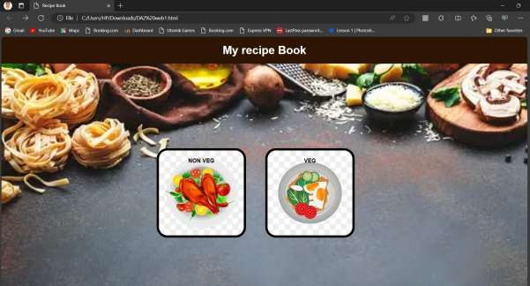

**If we press Non veg**

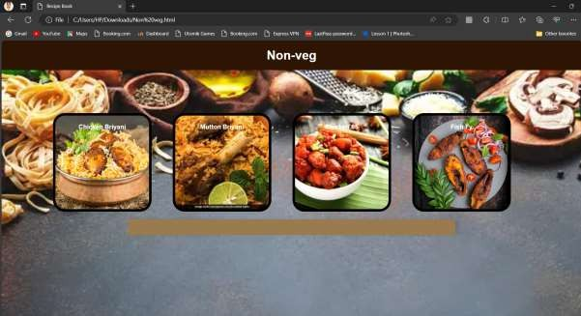

**If we click chicken briyani**

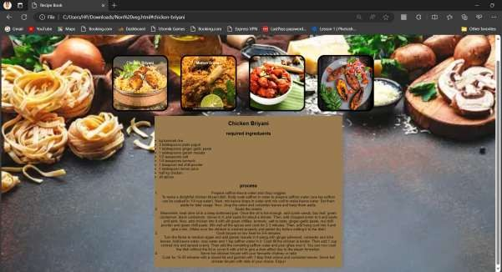

**If we click Mutton Briyani**

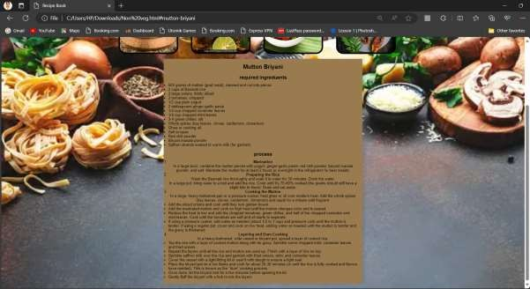

**If we click Chicken 65**

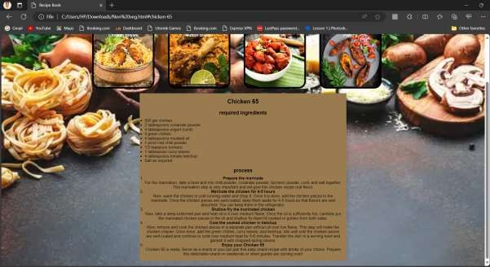

**If we click fish fry**

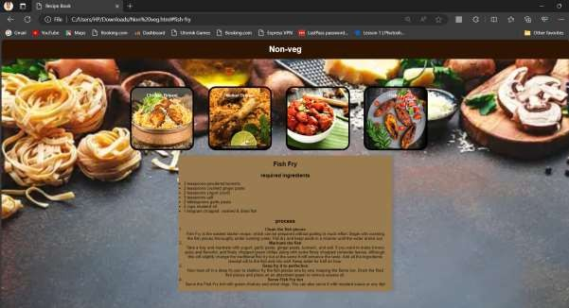

**Home page:**



**If we click veg**

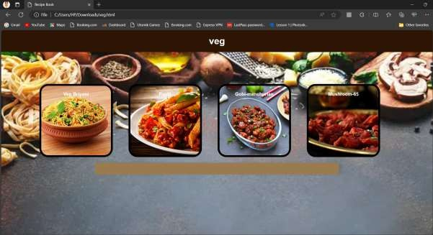

**If we click veg briyani**

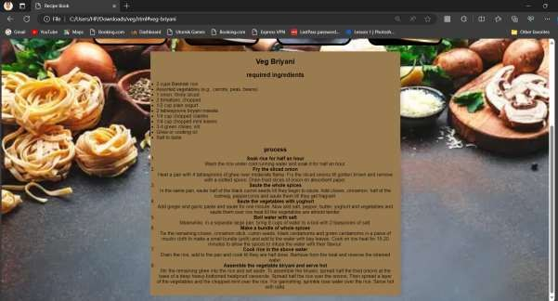

**If we click pasta**

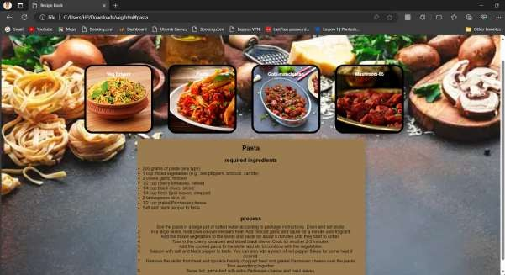

**If we click Gobi Manchurian**

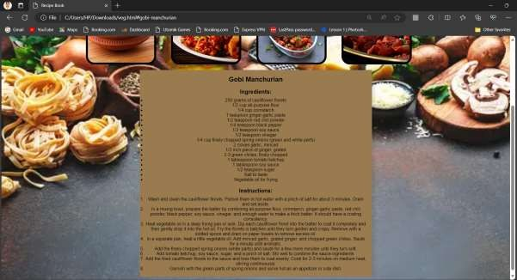

**If we click mushroom 65**

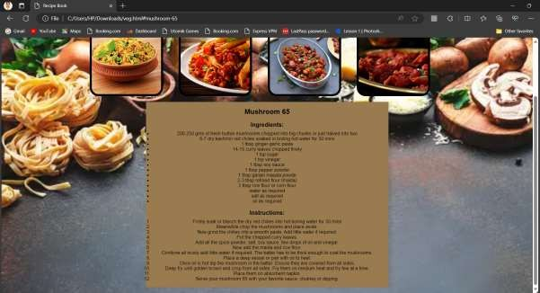

**Codes Css code:**

body,h1,h2,p,ul,ol,li{ margin:0; padding:0;

}

body{

font-family: Arial, sans-serif;

background-image:url('C:/Users/HP/Downloads/istockphoto-1472248473-170667a.webp'); background-size: cover;

background-repeat: no-repeat; background-attachment: fixed;

}

header {

background-color:#2E1503; color: white;

text-align: center; padding: 20px;

}

main {

max-width: 800px; margin: 20px auto; padding: 20px;

background-color:#9A7B4F ;

box-shadow: 10px 0px 10px rgba(0, 0, 0, 0.1);

}

h2 {

font-family: Arial, sans-serif;

font-size: 24px; margin-bottom: 10px;

}

h3 {

font-family: Arial, sans-serif;

font-size: 20px; margin-bottom: 10px;

}

.nav-image {

width: 200px; height: 200px;

}

.centered-container { text-align: center;

}

.centered-container ul { text-align: left;

}

.nav-item-non-veg { display: inline-block; margin-right: 50px;

text-align: center;

background-image: url('C:/Users/HP/Downloads/download.jpeg'); background-size: cover;

background-repeat: no-repeat; background-position: center center; width: 200px;

height: 200px; padding: 20px;

border: 7px solid black; border-radius: 30px; position: relative;

}

.nav-item-veg { display: inline-block; margin-right: 50px;

text-align: center;

background-image: url('C:/Users/HP/Downloads/pngtree-vegetarian-food-vector-ai-png- image_3590350.jpg');

background-size: cover; background-repeat: no-repeat; background-position: center center; width: 200px;

height: 200px; padding: 20px;

border: 7px solid black; border-radius: 30px; position: relative;

}

.nav-item-chicken-briyani { display: inline-block; margin-right: 50px;

text-align: center;

background-image: url('C:/Users/HP/Downloads/chicken briyani.jpeg'); background-size: cover;

background-repeat: no-repeat; background-position: center center; width: 200px;

height: 200px; padding: 20px;

border: 7px solid black; border-radius: 30px; position: relative;

}

.nav-item-mutton-briyani { display: inline-block; margin-right: 50px;

text-align: center;

background-image: url('C:/Users/HP/Downloads/download (1).jpeg'); background-size: cover;

background-repeat: no-repeat; background-position: center center; width: 200px;

height: 200px; padding: 20px;

border: 7px solid black; border-radius: 30px; position: relative;

}

.nav-item-chicken-65 { display: inline-block; margin-right: 50px;

text-align: center;

background-image: url('C:/Users/HP/Downloads/download (2).jpeg'); background-size: cover;

background-repeat: no-repeat; background-position: center center; width: 200px;

height: 200px; padding: 20px;

border: 7px solid black; border-radius: 30px; position: relative;

}

.nav-item-fish-fry {

display: inline-block; margin-right: 50px;

text-align: center;

background-image: url('C:/Users/HP/Downloads/Chettinad-fish-fry-1B.jpg'); background-size: cover;

background-repeat: no-repeat; background-position: center center; width: 200px;

height: 200px; padding: 20px;

border: 7px solid black; border-radius: 30px; position: relative;

}

.nav-item-veg-briyani { display: inline-block; margin-right: 50px;

text-align: center;

background-image: url('C:/Users/HP/Downloads/veg briyani.jpg'); background-size: cover;

background-repeat: no-repeat; background-position: center center; width: 200px;

height: 200px; padding: 20px;

border: 7px solid black; border-radius: 30px; position: relative;

}

.nav-item-pasta { display: inline-block; margin-right: 50px;

text-align: center;

background-image: url('C:/Users/HP/Downloads/pasta.jpg'); background-size: cover;

background-repeat: no-repeat; background-position: center center; width: 200px;

height: 200px; padding: 20px;

border: 7px solid black; border-radius: 30px; position: relative;

}

.nav-item-gobi-manchurian { display: inline-block; margin-right: 50px;

text-align: center;

background-image: url('C:/Users/HP/Downloads/gobi.webp'); background-size: cover;

background-repeat: no-repeat; background-position: center center; width: 200px;

height: 200px; padding: 20px;

border: 7px solid black; border-radius: 30px; position: relative;

}

.nav-item-mushroom-65 { display: inline-block; margin-right: 50px;

text-align: center;

background-image: url('C:/Users/HP/Downloads/mushroom 65.jpg');

background-size: cover; background-repeat: no-repeat; background-position: center center; width: 200px;

height: 200px; padding: 20px;

border: 7px solid black; border-radius: 30px; position: relative;

}

**Home page code:**

<!DOCTYPE html>

<html>

<head>

<link rel="stylesheet" href="DA2 web.css">

<title>Recipe Book</title>

</head>

<body>

<header>

<h1>My recipe Book</h1>

</header>

<br><br><br><br><br><br><br><br><br><br><br><br><br>

<div style="text-align: center;">

<nav>

<div style="display: inline-block; margin-right: 50px;" class="nav-item-non-veg">

<a href="C:\Users\HP\Downloads\Non veg.html" style="text-decoration: none; color: black; font-weight: bold; text-align: center;">NON VEG</a>

</div>

<div style="display: inline-block; margin-right: 50px;" class="nav-item-veg">

<a href="C:\Users\HP\Downloads\veg.html" style="text-decoration: none; color: black; font- weight: bold; text-align: center;">VEG</a>

</div>

</nav>

</body>

</html>

**Non veg code:**

<!DOCTYPE html>

<html>

<head>

<link rel="stylesheet" href="DA2 web.css">

<style>

.recipe-section { display: none;

}

</style>

<title>Recipe Book</title>

</head>

<body>

<header>

<h1>Non-veg</h1>

</header>

<br><br><br><br><br><br>

<div style="text-align: center;">

<nav>

<div style="display: inline-block; margin-right: 50px;" class="nav-item-chicken-briyani">

<a href="#chicken-briyani" onclick="showRecipe('chicken-briyani')" style="text-decoration: none; color: white; font-weight: bold; text-align: center;">Chicken Briyani</a>

</div>

<div style="display: inline-block; margin-right: 50px;" class="nav-item-mutton-

briyani">

<a href="#mutton-briyani"onclick="showRecipe('mutton-briyani')" style="text-decoration: none; color: white; font-weight: bold; text-align: center;">Mutton Briyani</a>

</div>

<div style="display: inline-block; margin-right: 50px;" class="nav-item-chicken-65">

<a href="#chicken-65" onclick="showRecipe('chicken-65')" style="text-decoration: none; color: white; font-weight: bold; text-align: center;">Chicken 65</a>

</div>

<div style="display: inline-block; margin-right: 50px;" class="nav-item-fish-fry">

<a href="#fish-fry" onclick="showRecipe('fish-fry')" style="text-decoration: none; color: white; font-weight: bold; text-align: center;">Fish Fy</a>

</div>

</nav>

<main>

<section id="chicken-briyani" class="recipe-section">

<h2>Chicken Briyani</h2>

<h3>required ingreduents</h3>

<div class="centered-container">

<ul>

<li>kg basmati rice</li>

<li>3 tablespoons plain yogurt</li>

<li>1 tablespoons ginger garlic paste</li>

<li>1 tablespoons garam masala</li>

<li>1/2 teaspoons salt</li>

<li>1/4 teaspoons turmeric</li>

<li>1 teaspoon red chili powder</li>

<li>1 tablespoon lemon juice</li>

<li> half kg chicken</li>

<li>all spices</li>

</div>

<h3>process</h3>

</ul>

<div class="centered-container" class="recipe-section">

<p><ol>

<li>Prepare saffron-kewra water and chop veggies

<p>To make a delightful chicken biryani dish, firstly soak saffron in water to prepare saffron water (one tsp saffron

can be soaked in 1/4 cup water). Next, mix kewra drops in water and mix well to make kewra water.

Set them aside for later usage. Now, chop the onion and coriander

leaves and keep them aside.</p>

</li>

<li>Saute the onions

<p>Meanwhile, heat olive oil in a deep bottomed pan. Once the oil is hot enough, add cumin seeds, bay leaf, green cardamom, black cardamom, cloves in it, and saute for about a minute. Then, add chopped onion to it and saute until pink. Now, add chicken into it with slit green chillies, turmeric, salt to taste, ginger-garlic paste, red chilli powder and green chilli paste. Mix well all the spices and cook for 2-3 minutes. Then, add hung curd into it and give a mix. (Make sure the chicken is washed

properly and patted dry before adding it to the dish)</p>

</li>

<li>Cook biryani on low heat for 5-6 minutes

<p>Turn the flame to medium again and add garam masala in it along with ginger julienned, coriander and mint leaves. Add kewra water,

rose water and 1 tsp saffron water in it. Cook till the chicken is tender. Then add 1 cup cooked rice and spread evenly.

Then add the remaining saffron water and pour ghee over it. You can now cook the dish without the lid or cover it with a lid to give a dum-effect due to the steam formation.</p>

</li>

<li>Serve hot chicken biryani with your favourite chutney or raita

<p>Cook for 15-20 minutes with a closed lid and garnish with 1 tbsp fried onions and coriander leaves. Serve hot chicken biryani with raita of your choice. Enjoy!</p>

</li>

</ol></p>

</section>

<section id="chicken-65" class="recipe-section">

<h2>Chicken 65</h2>

<h3>required ingredients</h3>

<div class="centered-container">

<ul>

<li>500 gm chicken</li>

<li>2 tablespoons coriander powder</li>

<li>4 tablespoons yogurt (curd)</li>

<li>4 green chillies</li>

<li>4 tablespoons mustard oil</li>

<li>1 pinch red chilli powder</li>

<li>1/2 teaspoon turmeric</li>

<li>1 tablespoon curry leaves</li>

<li>4 tablespoons tomato ketchup</li>

<li>Salt as required</li>

</ul>

</div>

<h3>process</h3>

<div class="centered-container" class="recipe-section">

<ol>

<li><b>Prepare the marinade</b>

<p>For the marination, take a bowl and mix chilli powder, coriander powder, turmeric powder, curd, and salt together. This marination step is very important and will give this chicken recipe real flavor.</p>

</li>

<li><b>Marinate the chicken for 4-5 hours</b>

<p>Now, wash the chicken in cold running water and chop it. Once it is done, add the chicken pieces to the marinade. Once the chicken pieces are well-coated, keep them aside for 4-5 hours so that flavors are well absorbed. You can keep them in the refrigerator.</p>

</li>

<li><b>Shallow fry the marinated chicken</b>

<p>Now, take a deep-bottomed pan and heat oil in it over medium flame. Once the oil is sufficiently hot, carefully put the marinated chicken pieces in the oil and shallow fry them till cooked or golden from both sides.</p>

</li>

<li><b>Coat the cooked chicken in ketchup</b>

<p>Now, remove and cook the chicken pieces in a separate pan without oil over low flame. This step will make the chicken crispier. Once done, add the green chillies, curry leaves, and ketchup. Mix well until the chicken pieces are well-coated and continue to cook over medium heat for 5-6 minutes. Transfer the dish to a serving bowl and garnish it with chopped spring onions.</p>

</li>

<li><b>Enjoy your Chicken 65</b>

<p>Chicken 65 is ready. Serve as a snack or you can pair this easy snack recipe with drinks of your choice. Prepare this delectable snack on weekends or when guests are coming over!</p>

</li>

</ol>

</div>

</section>

<section id="fish-fry" class="recipe-section">

<h2>Fish Fry</h2>

<h3>required ingredients</h3>

<div class="centered-container">

<ul>

<li>3 teaspoons powdered turmeric</li>

<li>2 teaspoons crushed ginger paste</li>

<li>2 teaspoons yogurt (curd)</li>

<li>3 teaspoons salt</li>

<li>2 tablespoons garlic paste</li>

<li>2 cups mustard oil</li>

<li>1 kilogram chopped, washed & dried fish</li>

</ul>

</div>

<h3>process</h3>

<div class="centered-container" >

<ol>

<li><b>Clean the fish pieces</b>

<p>Fish Fry is the easiest starter recipe, which can be prepared without putting in much effort. Begin with washing the fish pieces thoroughly under running water. Pat dry and keep aside in a strainer until the water drains out.</p>

</li>

<li><b>Marinate the fish</b>

<p>Take a tray and marinate with yogurt, garlic paste, ginger paste, turmeric, and salt. If you want to make it more spicy and flavorful, add finely chopped green chilies along with some finely chopped coriander leaves. Although, this will slightly change the traditional fish fry but at the same it will enhance the taste. Add all the ingredients (except oil) to the fish and mix well. Keep aside for half an hour.</p>

</li>

<li><b>Deep fry it to perfection</b>

<p>Now heat oil in a deep fry pan to shallow fry the fish pieces one by one, keeping the flame low. Drain the fried fish pieces and place on an absorbent paper to remove excess oil.</p>

</li>

<li><b>Serve Fish Fry hot</b>

<p>Serve the Fish Fry hot with green chutney and onion rings. You can also serve it with mustard sauce or any dip!</p>

</li>

</ol>

</div>

</section>

<section id="mutton-briyani" class="recipe-section">

<h2>Mutton Briyani</h2>

<h3>required ingreduents</h3>

<div class="centered-container">

<p><ul>

<li>500 grams of mutton (goat meat), cleaned and cut into pieces</li>

<li>2 cups of Basmati rice</li>

<li>2 large onions, thinly sliced</li>

<li>2 tomatoes, chopped</li>

<li>1/2 cup plain yogurt</li>

<li>2 tablespoons ginger-garlic paste</li>

<li>1/4 cup chopped coriander leaves</li>

<li>1/4 cup chopped mint leaves</li>

<li>3-4 green chilies, slit</li>

<li>Whole spices (bay leaves, cloves, cardamom, cinnamon)</li>

<li>Ghee or cooking oil</li>

<li>Salt to taste</li>

<li>Red chili powder</li>

<li>Biryani masala powder</li>

<li>Saffron strands soaked in warm milk (for garnish)</li>

</div>

<h3>process</h3>

</ul></p>

<p><ol>

<li><b>Marination</b>

<p>In a large bowl, combine the mutton pieces with yogurt, ginger-garlic paste, red chili powder, biryani masala powder, and salt. Marinate the mutton for at least 2 hours or overnight in the refrigerator for best results.</p>

</li>

<li><b>Preparing the Rice</b>

<p>Wash the Basmati rice thoroughly and soak it in water for 30 minutes.

Drain the water.

<br>In a large pot, bring water to a boil and add the rice. Cook until it's 70-

80% cooked (the grains should still have a slight bite to them). Drain and set aside.</p>

</li>

<li><b>Cooking the Mutton</b>

<p>In a large, heavy-bottomed pan or a pressure cooker, heat ghee or oil over medium heat. Add the whole spices (bay leaves, cloves, cardamom, cinnamon) and sauté for a minute until fragrant.

<div class="centered-container">

<p><ul>

<li>Add the sliced onions and cook until they turn golden brown.</li>

<li>Add the marinated mutton and cook on high heat until the mutton changes color and is seared.</li>

<li>Reduce the heat to low and add the chopped tomatoes, green chilies, and half of the chopped coriander and mint leaves. Cook until the tomatoes are soft and oil starts to separate</li>

<li>If using a pressure cooker, add water as needed (about 1/2 to 1 cup) and pressure cook until the mutton is tender. If using a regular pot, cover and cook on low heat, adding water as needed until the mutton is tender and the gravy is thickened.</li>

</ul></p>

</div>

</p>

</li>

<li><b>Layering and Dum Cooking</b>

<p>In a heavy-bottomed, wide vessel or biryani pot, spread a layer of

cooked rice.

<div class="centered-container">

<p><ul>

<li>Top the rice with a layer of cooked mutton along with its gravy.

Sprinkle some chopped mint, coriander leaves, and fried onions.</li>

<li>Repeat the layers until all the rice and mutton are used up. Finish

with a layer of rice on top.</li> mint, and coriander leaves.</li> ensure a tight seal.</li>

<li>Sprinkle saffron milk over the rice and garnish with fried onions,

<li>Cover the vessel with a tight-fitting lid or seal it with dough to

<li>Place the biryani pot on a low flame and cook for about 20-30

minutes (or until the rice is fully cooked and flavors have melded). This is known as the "dum" cooking process.</li>

the lid.</li>

<li>Once done, let the biryani rest for a few minutes before opening

<li>Gently fluff the biryani with a fork to mix the layers.</li>

</ul></p>

</div>

</p>

</li>

</ol></p>

</div>

</section>

</main>

</div>

<script>

function showRecipe(recipeId) {

// Hide all recipe sections

const recipeSections = document.querySelectorAll('.recipe-section'); recipeSections.forEach(section => {

section.style.display = 'none';

});

// Show the selected recipe section

const selectedRecipe = document.getElementById(recipeId); selectedRecipe.style.display = 'block';

}

</script>

</body>

</html>

**Veg code:**

<!DOCTYPE html>

<html>

<head>

<link rel="stylesheet" href="DA2 web.css">

<style>

.recipe-section { display: none;

}

</style>

<title>Recipe Book</title>

</head>

<body>

<header>

<h1>veg</h1>

</header>

<br><br><br><br><br><br>

<div style="text-align: center;">

<nav>

<div style="display: inline-block; margin-right: 50px;" class="nav-item-veg-briyani">

<a href="#veg-briyani" onclick="showRecipe('veg-briyani')" style="text-decoration: none; color: white; font-weight: bold; text-align: center;">Veg Briyani</a>

</div>

<div style="display: inline-block; margin-right: 50px;" class="nav-item-pasta">

<a href="#pasta"onclick="showRecipe('pasta')" style="text-decoration: none; color: white; font-weight: bold; text-align: center;">Pasta</a>

</div>

<div style="display: inline-block; margin-right: 50px;" class="nav-item-gobi-

manchurian">

<a href="#gobi-manchurian" onclick="showRecipe('gobi-manchurian')" style="text- decoration: none; color: white; font-weight: bold; text-align: center;">Gobi-manchurian</a>

</div>

<div style="display: inline-block; margin-right: 50px;" class="nav-item-mushroom-65">

<a href="#mushroom-65" onclick="showRecipe('mushroom-65')" style="text-decoration: none; color: white; font-weight: bold; text-align: center;">Mushroom-65</a>

</div>

</nav>

<main>

<section id="veg-briyani" class="recipe-section">

<h2>Veg Briyani</h2>

<h3>required ingredients</h3>

<div class="centered-container">

<ul>

<li>2 cups Basmati rice</li>

<li>Assorted vegetables (e.g., carrots, peas, beans)</li>

<li>1 onion, thinly sliced</li>

<li>2 tomatoes, chopped</li>

<li>1/2 cup plain yogurt</li>

<li>2 tablespoons biryani masala</li>

<li>1/4 cup chopped cilantro</li>

<li>1/4 cup chopped mint leaves</li>

<li>3-4 green chilies, slit</li>

<li>Ghee or cooking oil</li>

<li>Salt to taste</li>

</div>

<h3>process</h3>

</ul>

<div class="centered-container" class="recipe-section">

<p><ol>

<li><b>Soak rice for half an hour</b>

<p>Wash the rice under cold running water and soak it for half an

hour.</p>

</li>

<li><b>Fry the sliced onion</b>

<p>Heat a pan with 4 tablespoons of ghee over moderate flame. Fry the sliced onions till golden brown and remove with a slotted spoon. Drain fried slices of onion on absorbent paper.</p>

</li>

<li><b>Saute the whole spices</b>

<p>In the same pan, saute half of the black cumin seeds till they begin to sizzle. Add cloves, cinnamon, half of the nutmeg, peppercorns and saute them till they get fragrant.</p>

</li>

<li><b>Saute the vegetables with yoghurt</b>

<p>Add ginger and garlic paste and saute for one minute. Now add salt, pepper, butter, yoghurt and vegetables and saute them over low heat till the vegetables are almost tender.</p>

teaspoons of salt.</p>

</li>

<li><b>Boil water with salt</b>

<p>Meanwhile, in a separate large pan, bring 8 cups of water to a boil with 2

</li>

<li><b>Make a bundle of whole spices</b>

<p>Tie the remaining cloves, cinnamon stick, cumin seeds, black

cardamoms and green cardamoms in a piece of muslin cloth to make a small bundle (potli) and add to the water with bay leaves. Cook on low heat for 15-20 minutes to allow the spices to infuse the water with their flavour.</p>

</li>

<li><b>Cook rice in the above water</b>

<p>Drain the rice, add to the pan and cook till they are half done. Remove from the heat and reserve the strained water.</p>

</li>

<li><b>Assemble the vegetable biryani and serve hot</b>

<p>Stir the remaining ghee into the rice and set aside. To assemble the biryani, spread half the fried onions at the base of a deep heavy-bottomed heatproof casserole. Spread half the rice over the onions. Then spread a layer of the vegetables and the chopped mint over the rice. For garnishing, sprinkle rose water over the rice. Serve hot with raita.</p>

</li>

</ol></p>

</section>

<section id="pasta" class="recipe-section">

<h2>Pasta</h2>

<h3>required ingredients</h3>

<div class="centered-container">

<ul>

<li>200 grams of pasta (any type)</li>

<li>1 cup mixed vegetables (e.g., bell peppers, broccoli, carrots)</li>

<li>2 cloves garlic, minced</li>

<li>1/2 cup cherry tomatoes, halved</li>

<li>1/4 cup black olives, sliced</li>

<li>1/4 cup fresh basil leaves, chopped</li>

<li>2 tablespoons olive oil</li>

<li>1/2 cup grated Parmesan cheese</li>

<li>Salt and black pepper to taste</li>

</div>

</ul>

<h3>process</h3>

<div class="centered-container" class="recipe-section">

<p><ol>

<li>Boil the pasta in a large pot of salted water according to package instructions. Drain and set aside.</li>

<li>In a large skillet, heat olive oil over medium heat. Add minced garlic and sauté for a minute until fragrant.</li>

<li>Add the mixed vegetables to the skillet and sauté for about 5 minutes until they start to soften.</li>

<li>Toss in the cherry tomatoes and sliced black olives. Cook for another 2-3 minutes.</li>

<li>Add the cooked pasta to the skillet and stir to combine with the vegetables.</li>

<li>Season with salt and black pepper to taste. You can also add a pinch of red pepper flakes for some heat if desired.</li>

<li>Remove the skillet from heat and sprinkle freshly chopped basil and grated Parmesan cheese over the pasta. Toss everything together.</li>

<li>Serve hot, garnished with extra Parmesan cheese and basil leaves.</li>

</ol></p>

</section>

<section id="gobi-manchurian" class="recipe-section">

<h2>Gobi Manchurian</h2>

<h3>Ingredients:</h3>

<ul>

<li>250 grams of cauliflower florets</li>

<li>1/2 cup all-purpose flour</li>

<li>1/4 cup cornstarch</li>

<li>1 teaspoon ginger-garlic paste</li>

<li>1/2 teaspoon red chili powder</li>

<li>1/4 teaspoon black pepper</li>

<li>1/2 teaspoon soy sauce</li>

<li>1/2 teaspoon vinegar</li>

<li>1/4 cup finely chopped spring onions (green and white parts)</li>

<li>2 cloves garlic, minced</li>

<li>1/2 inch piece of ginger, grated</li>

<li>2-3 green chilies, finely chopped</li>

<li>1 tablespoon tomato ketchup</li>

<li>1 tablespoon soy sauce</li>

<li>1/2 teaspoon sugar</li>

<li>Salt to taste</li>

<li>Vegetable oil for frying</li>

</ul>

<h3>Instructions:</h3>

<ol>

<li>Wash and clean the cauliflower florets. Parboil them in hot water with a pinch of salt for about 3 minutes. Drain and set aside.</li>

<li>In a mixing bowl, prepare the batter by combining all-purpose flour, cornstarch, ginger- garlic paste, red chili powder, black pepper, soy sauce, vinegar, and enough water to make a thick batter. It should have a coating consistency.</li>

<li>Heat vegetable oil in a deep frying pan or wok. Dip each cauliflower floret into the batter to coat it completely and then gently drop it into the hot oil. Fry the florets in batches until they turn golden and crispy. Remove with a slotted spoon and drain on paper towels to remove excess oil.</li>

<li>In a separate pan, heat a little vegetable oil. Add minced garlic, grated ginger, and chopped green chilies. Sauté for a minute until aromatic.</li>

<li>Add the finely chopped spring onions (white parts) and sauté for a few more minutes until they turn soft.</li>

<li>Add tomato ketchup, soy sauce, sugar, and a pinch of salt. Stir well to combine the sauce ingredients.</li>

<li>Add the fried cauliflower florets to the sauce and toss them to coat evenly. Cook for 2-3 minutes on medium heat, stirring continuously.</li>

<li>Garnish with the green parts of spring onions and serve hot as an appetizer or side

dish.</li>

</ol>

</section>

<section id="mushroom-65" class="recipe-section">

<h2>Mushroom 65</h2>

<h3>Ingredients:</h3>

<ul>

<li>200-250 gms of fresh button mushrooms chopped into big chunks or just halved into

two</li>

<li>6-7 dry kashmiri red chilies soaked in boiling hot water for 30 mins</li>

<li>1 tbsp ginger-garlic paste</li>

<li>14-15 curry leaves chopped finely</li>

<li>1 tsp sugar</li>

<li>1 tsp vinegar</li>

<li>1 tbsp soy sauce</li>

<li>1 tbsp pepper powder</li>

<li>1 tbsp garam masala powde</li>

<li>2-3 tbsp refined flour (maida)</li>

<li>2 tbsp rice flour or corn flour</li>

<li>water as required</li>

<li>salt as required</li>

<li>oil as required</li>

</ul>

<h3>Instructions:</h3>

<ol>

<li>Firstly soak or blanch the dry red chilies into hot boiling water for 30 mins</li>

<li>Meanwhile chop the mushrooms and place aside.</li>

<li>Now grind the chilies into a smooth paste. Add little water if required.</li>

<li>Put the chopped curry leaves.</li>

<li>Add all the spice powder, salt, soy sauce, few drops of oil and vinegar.</li>

<li>Now add the maida and rice flour.</li>

<li>Combine all nicely add little water if required. The batter has to be thick enough to coat the mushrooms.</li>

<li>Place a deep vessel or pan with oil to heat.</li>

<li>Once oil is hot dip the mushroom in the batter. Ensure they are

covered from all sides.</li>

<li>Deep fry until golden brown and crisp from all sides. Fry them

on medium heat and fry few at a time.</li>

<li>Place them on absorbent napkin.</li>

<li>Serve your mushroom 65 with your favorite sauce, chutney or

dipping.</li>

</ol>

</section>

</main>

</div>

<script>

function showRecipe(recipeId) {

// Hide all recipe sections

const recipeSections = document.querySelectorAll('.recipe-section'); recipeSections.forEach(section => {

section.style.display = 'none';

});

// Show the selected recipe section

const selectedRecipe = document.getElementById(recipeId); selectedRecipe.style.display = 'block';

}

</script>

</body>

</html>